Kirsty Bannister
Institute of Psychiatry, Psychology and Neuroscience, King’s College London, United Kingdom

EDUCATION:
- 2000-2003 University College of London, BSc in Pharmacology (first class honours)
- 2003-2004 Imperial College London, MRes in Biomedical Integrative Sciences
- 2004-2008 Imperial College London, PhD in Epigenetic Mechanisms

EXPERIENCE:
- 2008-2017 University College London, Postdoctoral research associate, Neuropharmacology of Pain
- 2017-2020 King’s College London, Lecturer (Neuropharmacology, Principal Investigator)
- 2020-current King’s College London, Senior Lecturer/Associate Professor

The Bannister laboratory receives funding from the Academy of Medical Sciences, Parkinson’s UK and the National Centre for the Replacement, Refinement and Reduction of Animals in Research (NC3Rs).

2020 ARTICLES:
- Neuropathic Pain: Mechanism-Based Therapeutics – January 2020
- Supraspinal Opioid Circuits Differentially Modulate Spinal Neuronal Responses in Neuropathic Rat – January 2020
- Activation of the descending pain modulatory system using cuff pressure algometry: Back translation from man to rat – April 2020
- The impact of bone cancer on the peripheral encoding of mechanical pressure stimuli – April 2020
- Central Nervous System Targets: Supraspinal Mechanisms of Analgesia – July 2020
- The stage specific plasticity of descending modulatory controls in a rodent model of cancer induced bone pain – October 2020
- The impact of paradigm and stringent analysis parameters on measuring a net conditioned pain modulation effect: A test, retest, control study – November 2020
- The Stage-Specific Plasticity of Descending Modulatory Controls in a Rodent Model of Cancer-Induced Bone Pain – November 2020

AWARD:
2017: KB was awarded the EFIC IBSA publication award

Eric Buchser
Pain Management and Neuromodulation Centre EHC Hospital,
Morges, Switzerland

EDUCATION:
- Professor Buchser specialised in anaesthesia in 1983, after obtaining a federal diploma in medicine and a doctorate in medicine.
- His postgraduate training included clinical fellowships at the Pain Clinic at the University of Washington in the United States, and in the Anaesthesia Department at the McGill University in Montreal, Canada.

EXPERIENCE:
- 1988-2014: Head of the Anaesthesia and Pain Management Services – Neuromodulation Centre, Hôpital de Morges, Switzerland
- October 2002: Privat-Docent & Maître d'Enseignement et de recherche, Faculty of Biology & Medicine, University of Lausanne – Switzerland
- October 2004-2014: Professor “Titulaire” in Anaesthesiology, Faculty of Biology & Medicine, University of Lausanne – Switzerland
- August 2015: Senior Consultant, Dept. Of Anaesthesia, Pain Management & Neuromodulation Centre, EHC Hospital of Morges, Switzerland
- Current Position → Senior Consultant, Department of Anaesthesia and Intensive Care, Pain Management and Neuromodulation Centre, EHC-Hospital of Morges, Switzerland

He is well published in the area of pain management and neuromodulation, and has written several book chapters. Professor Buchser is a reviewer for the European Journal of Anaesthesia and the European Journal of Cardiothoracic Surgery, and has multiple teaching duties, including being an examiner at the Swiss Examination of Anaesthesiology. He is a member of several national and international societies and a founding member of the Swiss Society of Palliative Care Medicine.

2020 ARTICLES:
- Reply to Sharma et al – October 2020
- Analgesic Efficacy of “Burst” and Tonic ( 500 Hz ) Spinal Cord Stimulation Patterns: A Randomized Placebo‐Controlled Crossover Study – November 2020

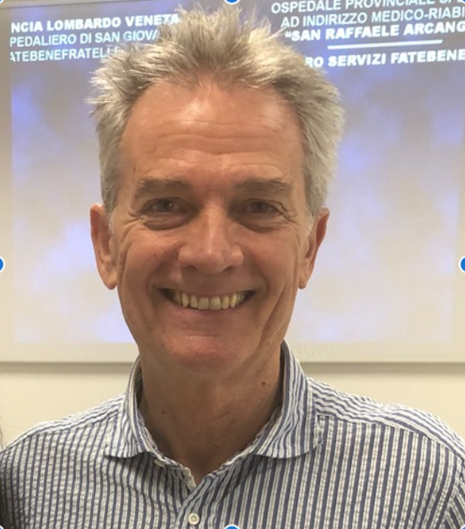
Roberto Casale
OPUSmedica, Patients, Care & Research PC&R, Piacenza, Italy

EDUCATION:
- Dr. Roberto Casale obtained the specialization in Neurology in 1979
- In 1980 attended a postgraduate course on Clinical neurophysiology
- In 1989 he also specialized in anesthesia and intensive care
- In 2010 he obtained a PhD in Advanced Technology in Rehabilitation Medicine

EXPERIENCE:
- January 1980-September 2015: Head at Istituti Clinici Scientifici Maugeri IRCCS – Dept. Clinical Neurophysiology & Pain rehabilitation unit, Italy
- October 2015-2018: Scientific Director at Habilita, Care & Research Rehabilitation Hospitals - Pain rehabilitation Unit & High Technology Rehabilitation Dept. Zingonia Bergamo, Italy
- Currently: Director OPUSMedica PC&R Network, Persons Care & Research Network

2020 ARTICLES:
- Community ambulation in people with lower limb amputation: An observational cohort study. Medicine (Baltimore). 2021
- Localized muscle vibration in the treatment of motor impairment and spasticity in post-stroke patients: a systematic review. European Journal of Physical and Rehabilitation - 2020
- Improvement of motor performance in children with cerebral palsy treated with exoskeleton robotic training: A retrospective explorative analysis - 2020
- Upper Limb Interactive Weightless Technology-Aided Intervention and Assessment Picks Out Motor Skills Improvement in Parkinson's Disease: A Pilot Study – Front Neurol 2020
- Lower Tinetti scores can support an early diagnosis of spatial neglect in post-stroke patients – European Journal of Physical and Rehabilitation 2020
- T helper 1 response is correlated with widespread pain, fatigue, sleeping disorders and the quality of life in patients with fibromyalgia and is modulated by hyperbaric oxygen therapy. Clin Exp Rheumatol. 2020

Jean-Francois Chenot
Department of General Practice, Institute for Community Medicine, University Medicine
Greifswald, Germany

EDUCATION:
- June 1992-September 1994: Claude Bernard University Lyon 1 in Medicine
- July 1998-July 2001: Carney Hospital in Residency Primary Care/Internal Medicine
- June 2000-August 2001: Boston University in Public Health

EXPERIENCE:
- Jean-Francois Chenot is head of the department of General Practice in Greifwald.
- He was formerly Prof. of Health Services Research at the department of General Practice in Göttingen (2001-2011) He continues to practice as GP in a rural practice in part time.

2020 ARTICLES:
- Referral criteria for chronic kidney disease - implications for patient management and healthcare expenditure – December 2020
- ISBT 2020 - Poster - anemia is not correlated with anemia symptoms – December 2020
- Anemia Symptoms are not predictive of anemia in the general population - analysis of two population based cohorts – December 2020
- The management of non–dialysis-dependent chronic kidney disease in primary care – November 2020
- The effects of incidental findings from whole-body MRI on the frequency of biopsies and detected malignancies or benign conditions in a general population cohort study – October 2020
- Association of anemia with clinical symptoms commonly attributed to anemia - analysis of two population based cohorts September 2020
- The effects of incidental findings from whole-body MRI on the frequency of biopsies and detected malignancies or benign conditions in a general population cohort study – August 2020
- Recall accuracy of notifications about incidental findings from an MRI examination: results from a population-based study – July 2020
- Dual renin‐angiotensin‐aldosterone blockade: Implementation of published research and Dear Doctor letters in ambulatory care: A retrospective observational study using prescription data – March 2020
- Frequency of thyroid function tests and examinations in participants of a population-based study – January 2020
- Evaluation of an ambulatory geriatric rehabilitation program - results of a matched cohort study based on claims data – January 2020

Gillian Chumbley
Imperial College Healthcare NHS Trust,
Charing Cross Hospital
London, United Kingdom

EDUCATION:
- 1978-1981: St Thomas’ Hospital, London, RGN Nursing
- 1992-1994: University of Surrey, UK, BSc (Hons) Health Studies (first class honours)
- 1996-2000: St George’s Hospital Medical School, University of London – PhD investigating Patients’ evaluations of patient-controlled analgesia after surgery

EXPERIENCE:
- Dr Gillian Chumbley is the Consultant Nurse in the pain service at Imperial College Healthcare NHS Trust.
- She has worked in pain management for over 27 years, the last 18 years at Imperial.
- She received a post-doctoral lectureship grant from the National Institute for Health Research and her research interests include the use of ketamine for complex pain, the use of opioids of persistent pain, pain and microbiome and the safety of intravenous infusions.
- She leads a team of highly educated nurses at Imperial and is a Visiting Senior Lecturer to the Florence Nightingale Faculty of Nursing, Midwifery and Palliative Care at King’s College.
- She is a member of the Royal Society of Medicine’s pain council and a member of the organising committee for the National Acute Pain Symposium.

2020 ARTICLES:
- The Potential Role of Smart Infusion Devices in Preventing or Contributing to Medication Administration Errors: A Descriptive Study of 2 Data Sets – August 2020
- Intravenous infusion practices across England and their impact on patient safety: a mixed-methods observational study – February 2020

RESEARCH PROFILE:

Gillian Chumbley (researchgate.net)

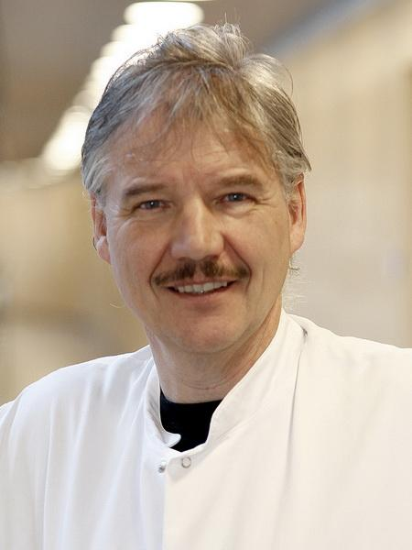
Asbjørn Mohr Drewes
Mech-Sense. Department of Gastroenterology & Hepatology,
Aalborg University Hospital, Denmark

Professor Asbjørn Mohr Drewes gained his medical degree from Aarhus University, Denmark in 1983. He defended a Ph.D. thesis at Aalborg University in 1998 and a doctoral thesis (DMSc) at Aarhus University in 1999. Prof Drewes is specialist in internal medicine, gastroenterology and hepatology. He also holds a European Master in Pain Medicine. Since 1999 he has been Professor (Chair) at the Department of Gastroenterology and Hepatology, Aalborg University Hospital. He is also Director of the research group Mech-Sense (www.mech-sense.com) and the Centre for Pancreatic Diseases at Aalborg University Hospital.
Prof Drewes is author of about 600 publications and has presented more than 500 oral and poster presentations at scientific meetings. He has an H-index of 55, and is a widely recognised expert in visceral pain pancreatology, analgesics, motility and brain-gut interactions. As such he is a frequent speaker and chairman at international congresses, and has been organizer of many international meetings. Currently he is a member of the scientific board of European Society of Neurogastroenterology and since 2012 he has been the President of Scandinavian Association for Neurogastroenterology and Motility.
He has received several awards and he’s research has been funded from many different national and international foundations such as the Danish Agency for Science, Technology and Innovation, National Institute of Health, EU 7th Framework Programme (grant No. # 223630), a research grant (#10-092786/DSF) offered by the Danish Agency for Science, Technology and Innovation, and the very prestigious “Hagedorn Prize” from Novo Nordisk Foundation. He was assigned the prestigious “Hagedorn Prize” by Danish Association of Internal Medicine in 2018 and the “Generalkonsul Ernst Carlsens” Prize in 2020. In May 2019 he was knighted (Order of the Dannebrog, R.) by Her Majesty Queen Margrethe II of Denmark.
Prof Drewes has supervised 48 Ph.D. students and is currently supervisor for 10. He teaches medical students and students in health technology at Aalborg University and gives lectures for postdocs in pancreatology, pain, gastroenterology and pharmacology. His current research interests include visceral pain, diseases of the pancreas, pharmacology of analgesics, motility, electrophysiology and imaging.
BIBLIOGRAPHY:
https://vbn.aau.dk/en/persons/107219/publications/

Geert Dom
Collaborative Antwerp Psychiatric Research Institute (CAPRI),
Antwerp University (UA)
Belgium

EDUCATION:

Geert Dom, MD, PhD, received his training in psychiatry and psychotherapy at the Antwerp University in Belgium (1976-1989). He has specialized in addiction psychiatry since 1992.

EXPERIENCE:
- Full Professor Psychiatry University of Antwerp.
- Vice-chair Collaborative Antwerp Psychiatric Research Institute (CAPRI)
- Medical Director PC Multiversum, Boechout, Belgium.
- President European Federation of Addiction Societies (EUFAS, http://www.eufas.net )
- Chair of Section on Addictive Behaviors, European Psychiatric Association (EPA, https://www.europsy.net ).
- Treasurer, European Psychiatric Association (EPA, https://www.europsy.net ).
- President Belgian Professional Association of Medical Specialists in Psychiatry.

2020 - 2021 ARTICLES:
Geert Dom (co) authored more than 200 peer reviewed articles and book chapters focussing on the pathogenesis and treatment of addictive disorders. Topics on which he also edited five books. A full bibliography can be found at https://anet.be/desktop/irua

Winfried Häuser
Department Internal Medicine 1
Klinikum Saarbrücken
Germany

EDUCATION:
- 1976-1982: Studies of human medicine and psychology at the University of the Saarland

EXPERIENCE:
- Prof. Dr. Med. Winfried Häuser is a specialist of general internal medicine, psychosomatic medicine and pain medicine.
- He is senior consultant for gastroenterology, hepatology, oncology, infectious diseases and psychosomatic medicine, Department of Internal Medicine I, Klinikum Saarbrücken Germany.
- He is adjunct professor of the Department of Psychosomatic Medicine and Psychotherapy of the Technical University Munich, Germany
- From 2004-2014, he served as General Secretary of the German Interdisciplinary Pain Society (DIVS).
- He is member of the advisory committee of the German Pain Society since 2012
- He was president of the German Pain Congress 2017
- He is currently working as senior physician in the department internal medicine 1 (gastroenterology, hepatology, endocrinology, infectiology, oncology) and as consultant in psychosomatic medicine and pain medicine in the ambulatory health care center, Saarbrücken St. Johann.

His main clinical and research interests are drug and psychological therapies of chronic functional pain syndromes (fibromyalgia, IBS, chronic pelvic pain) and cancer pain.

He is co-editor of the Cochrane Pain, Palliative and Supportive Care Group. He has published systematic reviews on drug therapies (antidepressants, anticonvulsants, cannabis-based medicines, opioids, NSAIDs) and on psychological therapies in chronic pain syndromes. He is the head of the steering committee of the German guidelines on fibromyalgia, and opioids in chronic non-cancer pain. He was a member of the steering group of the EULAR recommendations on the management of fibromyalgia. He is the head of the task force on cannabis-based medicines for chronic pain management of the European Pain Federation.

RESEARCH PROFILE:
https://www.researchgate.net/profile/Winfried_Haeuser

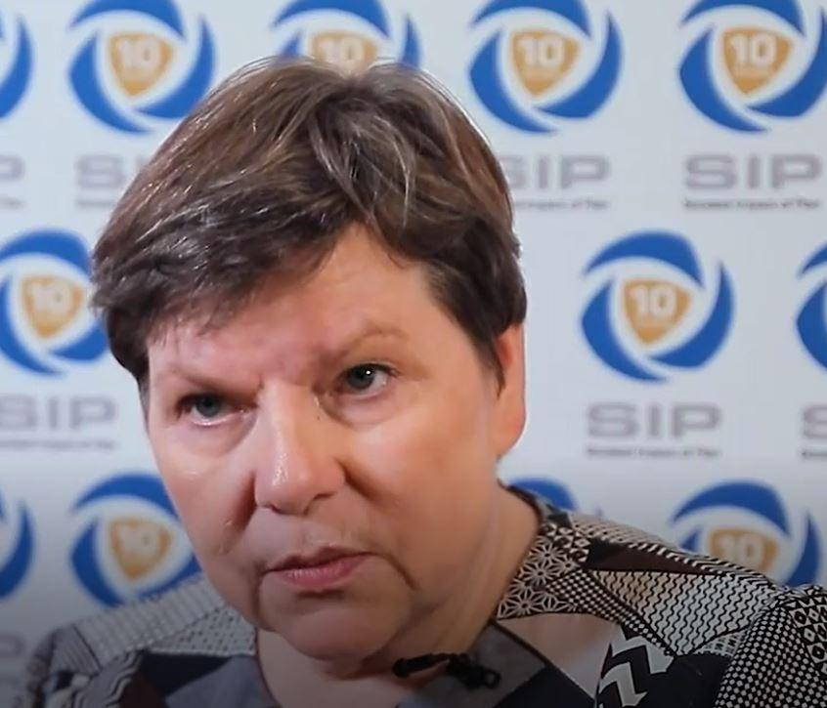
Liisa Jutila
Pain Alliance Europe
Finland

EDUCATION:
- 1997-1998: University of Plymouth
- 2014-2017: JAMK's Teacher Education College (Jyväskylä, Finland) →Vocational Teacher Education, Teaching, Post-graduate

EXPERIENCE:
- 2011-2014: Board Member representing PAE in different European organisations, healthcare professionals, policy makers, politicians and other Patient organisations.
- 2019-Present: Vice President PAE.

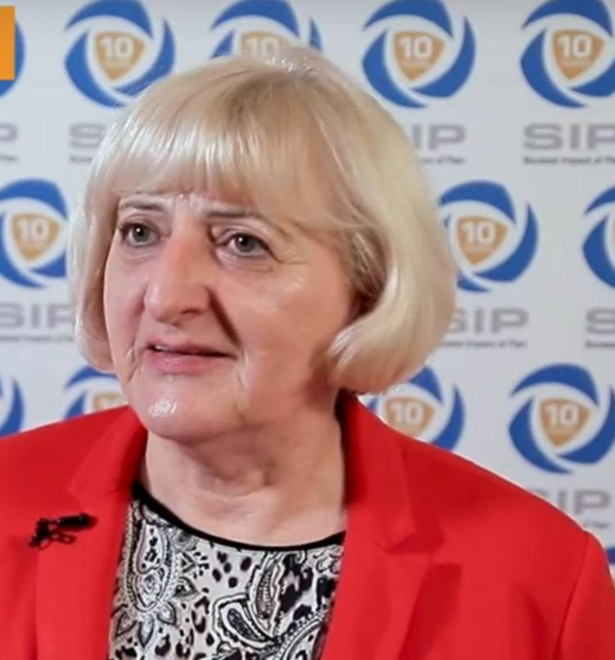
Nevenka Krcevski Škvarč
Medical center Maribor,
Faculty of Medicine of University Maribor,
Slovenia

EDUCATION:
- MD, University Zagreb in 1974
- Specialization in Anesthesiology and reanimatology, University Zagreb in 1981
- Master of science, University Zagreb in 1988
- PhD, Assist. prof., University Maribor in 2010
- Additional knowledge in palliative Care, SZPHO 2012
- EDPM, EFIC 2017

EXPERIENCE:
- Nevenka Krcevski Skvarc is retired anesthesiologist, partially working in Palliative Care Unit at University Medical Center Maribor, Slovenia
- She is active at Faculty of Medicine University of Maribor as a lecturer and mentor in Anesthesiology, Pain Medicine and Palliative Care. At the Faculty, she has the position of the Head of Institute of Palliative Medicine and Care.
- She is active as a lecturer and mentor at College of Health Science in Celje, Slovenia.
- She is the founder of Slovenian Association for Pain Management in 2006 and has been the first President for nine years, after that a member of Associations Council.
- She is the EFIC Councilor, and from 2011 until 2017 she has been the Honorary Secretary of European Pain Federation EFIC.

LATEST ARTICLES:
- Ebert Moltara, M., Pekarović Džakulin, V., Homar, V., Ivanetič Pantar, M., Kolšek Šušteršič, M., Koritnik, B., Lunder, U., Malačič, S., Papuga, V., Zelko, E., Žist, A., Ribarič Zupanc, V., Krčevski Škvarč, N. Paliativna oskrba v obdobju epidemije s covidom-19. Zdrav Vestn.(2020):89 (11-12): 658-70. doi.org/10.6016/Zdrav Vestn.3091.
- Bennet, M.I., Eisenberg, E., Ahmedzai, S.H., Bhaskar, A., O’Brien, T., Mercadante, S., Krčevski Škvarč, N., Vissers, K., Wirz, S.,Wells, C., Morlion, B. Standards for the management of cancer‐related pain across Europe. A position paper from the EFIC Task Force on Cancer Pain. European Journal of Pain (2019) 23(4); 660-668. doi:10.1002/ejp 1346.

Krcevski Skvarc, N. Wells, C., Houser, W. Availability and approval of cannabis-based medicines for chronic pain management and palliative/supportive care in Europe: a survey of the status in the chapters of the European Pain Federation. European Journal of Pain (2018) 22(3);440-454. doi.org/10.1002/ejp.1147.

Houser, W., Finn, D.P., Kalso, E., Krcevski Skvarc, N., Kress, H-G., Morlion, B., Perrot, S., Schaefer, M., Wells, C., Brill, S. European Pain Federation (EFIC) position paper on appropriate use of cannabis-based medicines and medical cannabis for chronic pain management. European Journal of Pain (2018) 22(9), 1547-1564. doi:10.1002/ejp.1297.

AWARDS

Silver key, University Maribor, 2007
Award from Faculty of Medicine, 2016
EFIC Pain Champion, 2017
Award for lifespan work, Slovenian Association for Anesthesiology and Perioperative Medicine, 2018

Bart Morlion, MD, PhD, DEAA, EDPM
Center for Algology & Pain Management,
University Hospitals Leuven,
Leuven, Belgium

Bart Morlion trained as an anesthesiologist but works since over 25 years full time in pain medicine. He is the director of the Leuven Centre for Algology & Pain Management at the University Hospitals of Leuven and clinical professor at the University of Leuven, where he teaches pain management, pharmacology and evidence based medicine at the medical school.
He ended his term as president of the European Pain Federation EFIC in September 2020 and is serving currently as Immediate Past President in the executive board of EFIC. He is past president of the Belgian Pain Society (2006-2012). He is program director of the Belgian Interuniversity Postgraduate Studies in Algology and is also an active member of several committees in international scientific societies. Bart Morlion was deputy editor of the European Journal of Pain till September 2020 and author of numerous publications on the management of pain. His professional interests include all aspects of multimodal chronic pain management, including pharmacotherapy and the role of nutrition in pain.
BIBLIOGRAPHY:
http://lirias.kuleuven.be/cv?Username=U0044030

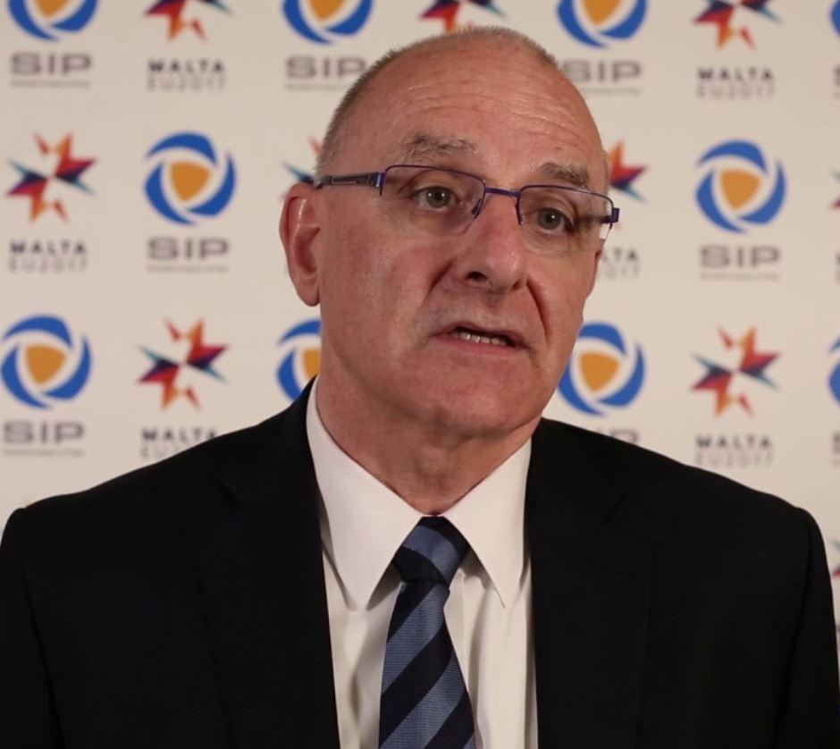
Tony O’Brien
College of Medicine & Health, University College Cork,
Republic of Ireland

EDUCATION:
- Prof O’Brien undertook his post graduate training at St Christopher’s Hospice, London in the mid-1980s and has held his current position since 1991.

EXPERIENCE:
- Prof Tony O’Brien is a consultant physician in palliative medicine at Marymount University Hospital & Hospice / Cork University Hospital and clinical professor of palliative medicine at the College of Medicine & Health, University College Cork, Ireland.
- He chaired the Irish Government’s National Advisory Committee on Palliative Care and subsequently was appointed as Chairperson of the National Council for Specialist Palliative Care.
- He also served as chairperson of the Council of Europe Expert Committee on Palliative Care. Prof O’Brien has published and lectured extensively on various aspects of pain and palliative care.

LATEST ARTICLES:
- Pathophysiology and management of opioid-induced constipation: European expert consensus statement – December 2018
- Standards for the management of cancer‐related pain across Europe. A position paper from the EFIC Task Force on Cancer Pain – November 2018

Esther Pogatzki-Zahn
Department of Anaesthesiology, Intensive Care and Pain Medicine
University Hospital Muenster UKM,
and Westfälische Wilhelms University,
Muenster

EDUCATION:
MD (1996), Anesthesiologist (2004), PhD training in neuroscience (1998-2003) in the US (Baltimore and Iowa City), Pain Specialist (2016)
EXPERIENCE:
- Prof. Esther Pogatzki-Zahn is an anesthesiologist and pain specialist in the Department of Anaesthesiology, Intensive Care and Pain Medicine, University Hospital Muenster, Germany. She is head of the pain service at the University Clinic in Muenster since 14 years.
- As a full professor in Anesthesiology and Pain Medicine, she is PI of the “Translational Pain Research” group. This group is aiming to provide insight into the neuropathology of incisional, chronic inflammatory, neuropathic and cancer related pain by using behavioral, electrophysiological and in-vitro studies in rodents; here she cooperates with a number of international researchers in the field of omics, optogenetics and imaging. Furthermore, she performs human experimental and clinical studies including psychophysical testing, the development of patient-reported outcome measures (PROM) in patients and new strategies able to treat and prevent pain. She performs Systematic Reviews and Cochrane Analysis.
- She has teaching responsibilities at the Westfälische Wilhelms University of Muenster, Germany.
Prof. Pogatzki-Zahn is a member of the Prospect Initiative (www.postoppain.org) and the DFNS e.V.. She is a Council member of the IASP (2018-2023) and the German IASP chapter, Chair of the Acute Pain SIG of the IASP and past chair of the Pain and Palliative Group of the European Society of Anaesthesiologists and Debuty Editor in Chief of the European Journal of Anesthesiologists.
She has been working in the field of acute and acute to chronic pain since 20 years and has published more than 150 articles, more than 10 book chapters and 3 books in the area of pain.
LATEST ARTICLES (2020-now):
- Assessing outcome in postoperative pain trials: are we missing the point? A systematic review of pain-related outcome domains reported in studies early after total knee arthroplasty. January 2021
- Desire to receive more pain treatment - a relevant patient-reported outcome measure to assess quality of post-operative pain management? Results from 79,996 patients enrolled in the pain registry QUIPS from 2016 to 2019. January 2021
- Prediction and prevention of chronic postoperative pain. January 2021
- Pain management after open liver resection: Procedure-Specific Postoperative Pain Management (PROSPECT) recommendations. January 2021
- Prevalence of Postoperative Pain Following Hospital Discharge: Protocol for a Systematic Review. December 2020
- Safety and monitoring of patient-controlled intravenous analgesia: Clinical practice in German hospitals. December 2020
- Pectoral nerve blocks for breast surgery: A meta-analysis. November 2020
- PROSPECT guideline for tonsillectomy: systematic review and procedure-specific postoperative pain management recommendations. November 2020
- Comparison of continuous versus patient-controlled dosing regimen in peripheral nerve blocks for postoperative pain management after lower extremity surgery: A data-base analysis of 1293 cases. September 2020
- Incidence, Time Course and Influence on Quality of Life of Intensive Care Unit-Acquired Weakness Symptoms in Long-Term Intensive Care Survivors. August 2020
- Developing consensus on core outcome domains and measurement instruments for assessing effectiveness in perioperative pain management after sternotomy, breast cancer surgery, total knee arthroplasty, and surgery related to endometriosis. August 2020
- Predicting poor postoperative acute pain outcome in adults: an international, multicentre database analysis of risk factors in 50,005 patients. July 2020
- Peripheral Sensitization and Loss of Descending Inhibition Is a Hallmark of Chronic Pruritus. March 2020
- Pain thresholds and intensities of CRPS type I and neuropathic pain in respect to sex. February 2020
- Study on the self-treatment of migraine among German neurologists and pain specialists. February 2020
- Diagnostic utility of small fiber analysis in skin biopsies from children with chronic pain. January 2020
- Real-world use of the sufentanil sublingual tablet system for patient-controlled management of acute postoperative pain: a prospective noninterventional study. January 2020
- The role of the spinal cyclooxygenase (COX) for incisional pain in rats at different developmental stages. January 2020

AWARDS:
Prof. Pogatzki-Zahn won a number of national and international research awards like the German Research Grant, IASP Collaboration Research Award, the EFIC Grünenthal Grant (E-G-G) and the Clinical scholar research award of the IARS, among others.

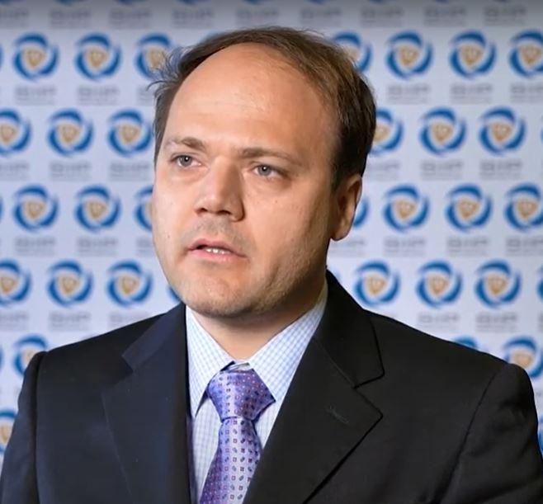
Martin Rakusa
Department of Neurology, University Medical Centre Maribor
Slovenia

EXPERIENCE:
- Professor Martin Rakusa is consultant neurologist at the Department of Neurology of the University Medical Centre in Maribor, Slovenia; he is also an assistant professor at the Faculty of Medicine, and Faculty of Health Sciences, University of Maribor.
- Professor Rakusa's clinical work involves treating patients with different types of dementia, and his current main research interest is in the higher cortical functions. He also performs electromyography and treats patients with muscle and nerve disorders.

He is a co-chair of the Scientific panel on Pain at the European Academy of Neurology.

2020 ARTICLES:
- Association of Cortical and Subcortical β-Amyloid With Standardized Measures of Depressive and Anxiety Symptoms in Adults Without Dementia – October 2020
- EAN consensus statement for management of patients with neurological diseases during the COVID-19 pandemic – October 2020
- Toward a unified European curriculum – reforming national residency program in Slovenia – July 2020
- Pitfalls in recognition and management of trigeminal neuralgia – June 2020
- The validity of the Montreal cognitive assessment (MoCA) for the screening of vascular cognitive impairment after ischemic stroke – March 2020
- Diagnostic and Therapeutic Errors in Classical Trigeminal Neuralgia: a Multicenter Survey – March 2020

BIBLIOGRAPHY:
https://scholar.google.si/citations?user=XuBRfHUAAAAJ&hl=sl&oi=ao

AWARDS:
2007/2008 Chevening Scholarship; UCL Queen Square Institute of Neurology, London, UK.
2019/2020 Fulbright Scholarship; Mayo Clinic, Rochester, MN, USA.

Carmen Suarez-Serrano
Department of Physiotherapy, University of Seville
Spain

EDUCATION:
● 1995: Degree in Nursing - University of Cordoba
● 1999: Degree in Physiotherapy. University of Seville
● 2008: PhD Degree - University of Seville

EXPERIENCE:
● 2018- present. Vicedean of Innovation, Postgraduate studies and research. Faculty of Nursing, Physiotherapy and Podiatry. University of Seville
● 2005-present. Lecturer in the Physiotherapy Department in Seville University. Spain
● Researcher of Physiotherapy and women’s health. Group "Area of Physiotherapy” CTS-305 (2001 at present). University of Seville, Spain

BIBLIOGRAPHY:
https://investigacion.us.es/sisius/sis_showpub.php?idpers=7550
ResearcherID: F-1493-2018
ORCID: https://orcid.org/0000-0003-1485-5811

Thomas Tölle
Department of Neurology, Technische Universität München
Germany

EDUCATION:
- Professor Tölle completed his study of medicine and psychology at the Universities of Bochum, Frankfurt, Düsseldorf and Munich.
- He earned his PhD (Dr. rer. nat.) at the Natural Sciences Faculty of the University of Düsseldorf and completed the doctoral part of his medical training at LMU Munich using fundamental research performed at Max-Planck-Institute for Psychiatry.

EXPERIENCE:
- He subsequently held research posts at the Institute for Histology, University of Porto, Portugal, and at MRC, Cambridge, England, in the Neurobiology Department. This was followed by clinical work at Max-Planck-Institute for Psychiatry.
- In 1995 he moved to the Neurological Department at TUM, and set up an interdisciplinary research group for clinical and experimental research into pain, focusing primarily on the neurobiological mechanisms of neuronal plasticity in pain, pharmacological treatment and central imaging with fMRI and PET.

2020 ARTICLES:
- Migraine Attacks as a Result of Hypothalamic Loss of Control – November 2020
- Dynamics of brain function in chronic pain patients assessed by microstate analysis of resting-state electroencephalography – October 2020
- Digital Treatment of Back Pain versus Standard of Care: The Cluster-Randomized Controlled Trial, Rise-uP – July 2020
- Less Pain, Better Sleep? The Effect of a Multidisciplinary Back Pain App on Sleep Quality in Individuals Suffering from Back Pain – a Secondary Analysis of App User Data – May 2020
- Longitudinal prevalence and determinants of pain in multiple sclerosis: results from the German National Multiple Sclerosis Cohort study – Aprile 2020
- Pain thresholds and intensities of CRPS type I and neuropathic pain in respect to sex – February 2020

AWARDS:
- designierter Präsident der Deutschen Gesellschaft zum Studium des Schmerzes e.V. (DGSS) (seit 1. Januar 2011)
- Sprecher des vom BMBF geförderten Deutschen Forschungsverbundes Neuropathischer Schmerz (DFNS) (seit 2002)
- Deutscher Schmerzpreis: Förderpreis für Schmerzforschung der DGSS (1990)
Kevin E. Vowles
School of Psychology, Queen's University Belfast,
Northern Ireland, United Kingdom

EDUCATION:
- Kevin Vowles completed his PhD in clinical psychology at West Virginia University in 2004 and post-doctoral fellowship at the University of Virginia the following year.

EXPERIENCE:
- From 2005 to 2009, he was employed in the United Kingdom by the Centre for Pain Research and Services at the University of Bath and Royal National Hospital for Rheumatic Diseases.
- Beginning in 2009, he accepted a position to provide psychology leadership in developing a novel interdisciplinary pain rehabilitation program delivered interface of primary and secondary care interface with Keele University. After three years of trial funding, this program was deemed by the UK’s National Health Service to be highly effective in both clinical and financial terms and permanent funding was secured. This service was awarded with the National Care Integration Award in 2012.
- That same year, Kevin moved to the Department of Psychology at the University of New Mexico, where he was promoted to Full Professor in 2019.
- Kevin is currently a Professor of Clinical Health Psychology at Queen’s University-Belfast, where he continues his work on effective treatments for those with chronic pain and on addressing co-morbid chronic pain and hazardous substance use.

He has been working in the field of chronic pain and illness for the majority of his career and has published more than 100 articles in the area since beginning his doctoral training in 2001.

2020 ARTICLES:
- Development and preliminary validation of the Chronic Pain Acceptance Questionnaire for clinicians - October 2020
- Comorbid chronic pain and opioid misuse in youth: Knowns, unknowns, and implications for behavioral treatment – September 2020
- Pain interference and catastrophizing are not associated with polysubstance use among treatment-seeking patients with substance use disorders and chronic pain - September 2020
- Initial Evaluation of the Chronic Pain Acceptance Questionnaire – 2 – August 2020
- A pilot study of integrated behavioral treatment for Veterans with co-morbid chronic pain and hazardous opioid use - July/August 2020
- A Contextual-Behavioral Perspective on Chronic Pain During the COVID-19 Pandemic and Future Times of Mandated Physical Distancing – July 2020
- Development and preliminary validation of the Chronic Pain Acceptance Questionnaire for Clinicians – July 2020
- Pain interference and catastrophizing are not associated with polysubstance use among treatment-seeking patients with substance use disorders and chronic pain – June 2020
- A comparative meta-analysis of unidisciplinary psychology and interdisciplinary treatment outcomes following Acceptance and Commitment Therapy for chronic pain - May/June 2020
- Acceptance and Action Questionnaire – II: Confirmatory Factor Analysis and measurement invariance between Non-Hispanic White and Hispanic/Latinx undergraduates – May 2020
- Mindfulness and meditative movement interventions for men living with cancer: A meta-analysis - April 2020
- A Non-randomized pilot study to test the feasibility of Treating chronic Pain and opioid prescription use in rural areas with Acceptance and Commitment Therapy (T-PACT) – March 2020
- Hope-related goal cognitions and daily experiences of fatigue, pain, and functional concern among lung cancer patients – February 2020
- Pain anxiety as a mechanism linking pain severity and opioid misuse and disability among individuals with chronic pain - January/February 2020
- Receipt of multiple outpatient opioid prescriptions is associated with increased risk of adverse outcomes in youth: opioid prescribing trends, individual characteristics, and outcomes from 2005-2016 – Jan. 2020
- Theoretical Grounds of Pain Tracker Self Manager: An Acceptance and Commitment Therapy Digital Intervention for Patients with Chronic Pain – January 2020

RESEARCH PROFILE:
https://pure.qub.ac.uk/en/persons/kevin-vowles

