

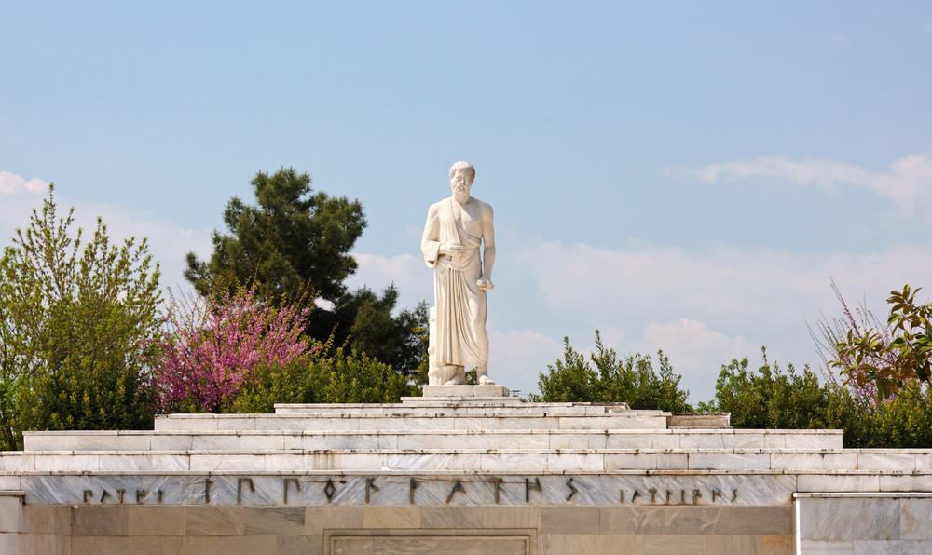
As to diseases make a habit of two things, to help or at least to do no harm
Hippocrates (Kos, 460BC – Larissa, 377 BC)

PHYSICAL AND REHABILITATION MEDICINE IN PAIN MANAGEMENT
Larissa, Greece, 25th-27th June 2026

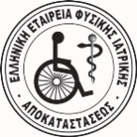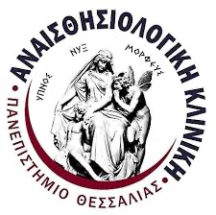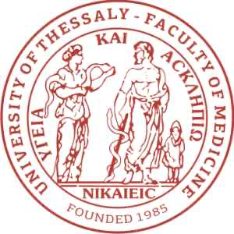

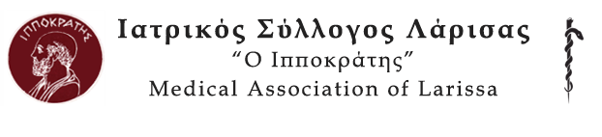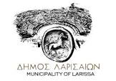
Endorsed by EFIC
Under the Auspicies of:
Hellenic Society of Algology, Hellenic Society of Physical Medicine & Rehabilitation,
Anesthesiology Department, Medical School, University of Thessaly,
2nd Neurosurgery Department, Medical School, National & Kapodistrian University of Athens,
Medical Association of Larissa,
Municipality of Larissa

Objectives: to increase awareness, knowledge and practical skill by using physical and rehabilitation medicine approach in chronic pain patient management.

Course Organisers:
Efthimios Kouloulas (EDPM, EFIC Academy member, Greece), Physiatriki Pain Management Center, Larissa, Greece
Indre Bileviciute Ljungar (Chair, EFIC Education Committee) Dept. Clinical Sciences Danderyd University Hospital, Karolinska Institute, Sweden

Location: « Physiatriki Pain Management Center », Rehabilitation Center, Larissa, Greece.

Board of Faculty:
Indre Bileviciute Ljungar, EDPM, PRM & Pain medicine physician, assoc. professor in Rehabilitation Medicine, Chair EFIC Education Committee, Stockholm, Sweden
Luis Garcia-Larrea, President EFIC, professor in Clinical Neurophysiology, Lyon, France
Daniel Ciampi de Andrade, specialist in Neurology, Aalborg Univ Hospital and CMAP, Denmark
Eleni Chrona, Consultant Anesthesiologist, Director Anesthesiology Dpt, General Hopsital “St Panteleemon”, Nikaia - Piraeus, President of the Hellenic Algology Society (HAS) , Greece
Eleni Arnaoutoglou, Professor of Anesthesiology, Faculty of medicine, University Hospital of Larissa
Metaxia Bareka, Assistant Professor of Anesthesiology, Faculty of medicine, University Hospital of Larissa
Katerina Bouzia, Assistant Professor of Anesthesiology, Faculty of medicine, University Hospital of Larissa
Marianthi Varveri, Consultant Anesthesiologist, General Hospital “Papageorgiou”, Thessaloniki, Greece
Eleni Koraki, Consultant Anesthesiologist, Director Anesthesiology Dpt, Papageorgiou Hospital, Thessaloniki, Greece,
Aristeidis Zimbis, Professor of Orthopedics, Dean Medical School of Larissa, University of Thessaly,
Steven Stanos, PRM & Pain medicine physician, Head of Pain services, Swedish Hospital, Seattle, Washington, USA
Efstathios Boviatsis, Professor of Neurosurgery, Head of 2nd Neurosurgery Dpt, National & Kapodistrian University of Athens, Attikon Hospital, Athens,
Efthimios Kouloulas, EDPM, SFEBPRM, PRM & Pain medicine physician, Director of “Physiatriki pain management center”, Larissa, Rehabilitation consultant, 2nd Neurosurgery Dpt, National & Kapodistrian University of Athens, Attikon Hospital,
Nikolaos Sorras, EDPM, PRM & Pain medicine physician, Director of PRM Dpt, 401 General Army Hospital, Athens
Markos Sgantzos, Professor of Anatomy & Physical Medicine & Rehabilitation, Medical School, University of Thessaly, President of Hellenic Physical Medicine & Rehabilitation Society, Larissa

Participants: Healthcare professionals including physicians, physical therapists, psychologists, nurses, occupational therapists and other rehabilitation specialists.

Introduction
Comprehensive, team-based management of chronic pain requires both pharmacological and non-pharmacological approaches as well as multidisciplinary pain rehabilitation when indicated. Careful assessment of an individual’s pain complains, a biopsychosocially- based history, focused physical examination, symptoms´ impact on functioning and activities are important to support our decisions what drugs should be prescribed and what physical and rehabilitation methods are indicated.
Physical and rehabilitation medicine should be comprehensive in chronic pain management and in some cases might be the only one which patient wants to try or is indicated due to drug intolerance and comorbidities. Today, physical and rehabilitation medicine combines both “passive” and “active” treatments in terms of pain relief and behavioral changes to enhance patient´s functioning and activity levels.

The aim of this joint pain school is to increase awareness of when to use physical and rehabilitation medicine in chronic pain management with and without pharmacological treatments and to provide practical skills when using evidence-based treatments, including multimodal pain rehabilitation.

The school´s structure will consist of half-day theoretical and half-day practical sessions. Day 1: Definitions, pathophysiology, mechanisms and diagnostic methods. Day 2: Therapeutic approaches in pain rehab, with focus on evidence and Day 3: Physical/rehab therapies for pain patients with special demands and the multimodal / interprofessional approach in physical and rehabilitation medicine. The participants will also get access to recommended material from the EFIC Academy to be read in advance. This pre-reading material will give a theoretical introduction to many topics in the program and will be linked to the topics in the program.

Target Audience: Different healthcare professionals working with chronic pain patients and wanted to learn more knowledge how to implement treatments and techniques depending on pain phenotypes and comorbidities. The school is intended for health care applicants from different professions facing chronic pain patients (physicians, physical therapists, occupational therapists, psychologists and other health care specialists in rehabilitation)

Maximum number of candidates: 25

Course Fee: 1000Ε

Day 1 (25th of June)

General theme: Introduction to pain mechanisms, chronic pain types and clinical examination

08:30 – 09:15. Anatomy and physiology of pain processes: from receptors to brain networks
Aristeidis Zimbis (chair) and Luis Garcia-Larrea

09:30 – 10:15 Mechanisms behind nociceptive, neuropathic and “nociplastic” or “primary” pain
Eleni Arnaoutoglou (chair) and Metaxia Bareka

10:15-10:45. Coffee break.

10:45-11:45 The Biopsychosocial model of pain and the ICF (International Classification of Functioning, Disability and Health) 60 min (includes 5 minutes break)
Steven Stanos

11:45 – 13:00 The clinical examination of pain patient
Indre Bileviciute Ljungar and Efthimios Kouloulas

Lunch 13.00-14.00

14:00-16:30 Group hands-on sessions – the role of pain analysis to orient treatment. How we do that? (coffee break between 15.00 to 15.30)
Practical investigations 2 hours (30 min x4 rotations) for understanding and training the skills for pain analysis. After short introduction the attendees will practice in pairs under supervision.
Four groups:
- nociceptive (osteoarthritis/ SIJ, Hip pain, chronic joint inflammation and inflammatory conditions in spine structures); supervisor Steven Stanos
- neuropathic (central and peripheral neuropathic pain); supervisor Daniel Ciampi de Andrade and Luis Garcia-Larrea
- mixed (low back pain + radiculopathy) supervisor Efthimios Kouloulas
- nociplastic pain (generalised/fibromyalgia and hypermobility disorders); supervisor Indre Bileviciute Ljungar

16:30- 17:00 Summary gathering

17.00 Visit to Hippocrates tomb & garden in Larissa
Dinner together
Day 2 (26th of June)

General theme: Grand classes of physical and rehabilitation therapies for pain

8:30-9:15. Neurostimulation: Theoretical knowledge on the mechanisms behind.
Luis Garcia-Larrea

9:15-10:00 Pain Neuromodulation in rehabilitation medicine– Evidence and indications of established techniques
  - Magnetic Peripheral Nerve Stimulation (mPNS) – Efthimios Kouloulas
  - Pulsed radiofrequency – Marianthi Varveri
  - Spinal cord stimulation – Efstathios Boviatsis
  - Brain stimulation: rTMS/tDCS – Luis Garcia Larrea & Daniel Ciampi

Coffee break 10:00-10:30

10:30-11:15 Pain Neuromodulation and other physical therapies, Evidence and indications Efthimios Kouloulas and Nikos Sorras
  - Heat, cold, - Nikolaos Sorras
  - TENS / PENS - Nikolaos Sorras
  - Ultrasound – Laser – Radiofrequency therapy - Efthimios Kouloulas
  - Extracorporeal shockwave treatment (ESWT) - Efthimios Kouloulas
  - Dry needling, Kinesio taping - Nikolaos Sorras

11:15-12:00 Exercise-based and mind-body techniques: evidence & indications
Steven Stanos and Efthimios Kouloulas
- Eccentric exercises - Efthimios Kouloulas
- Body movement-therapies: Pilates and Tai Chi – Efthimios Kouloulas
- Graded motor imagery – Virtual imagery - Biofeedback therapy – Steven Stanos
- Digital medicine and telehealth (Virtual Reality, tele medicine) – Steven Stanos

Short brake

12:10 – 13:00. Pharmacotherapy and Regenerative medicine in pain rehabilitation (“yes, you also use drugs”)
Indre Bileviciute-Ljungar, Efthimios Kouloulas & Katerina Bouzia
- Commonly first- and second line drugs Katerina Bouzia
- Botulinum toxin Indre Ljungar
- Platelet-rich plasma – Efthimios Kouloulas
- Hyaluronic agents – Efthimios Kouloulas

Lunch 13.00-14.00

14:00-16:30 Group hands-on sessions – different treatment modalities with practical exercises (coffee break between 15.00 to 15.30)

Practical sessions 2 hours (20 min x 6 rotations) for different treatment modalities. After short introduction the attendees will practice in pairs or with mannequins under supervision.
Four groups:
- Botulinum toxin
- Biofeedback therapy
- rTMS and mPNS
- Platelet-rich plasma & HA injections
- Shockwave treatment (rESWT & fEWST)
- Physical therapy modalities (PENS, Radiofrequency, HILaser)

16:30- 17:00 Summary gathering.

17.00 Visit to a Local Winery
Dinner together

Day 3 (27th of June)

General theme: How to adapt physical and rehabilitation therapies for pain patients?

08:30-08:50 Pain rehabilitation approach in children and adolescents.
Indre Bileviciute Ljungar

08:50-09:10 Neuro-rehabilitation in the elderly and patients with cognitive impairments.
Daniel Ciampi de Andrade
Short brake

09:20-09:40 Pain rehabilitation approach in cancer survivors
Eleni Chrona (chair) and Eleni Koraki

09:40-10:00 Pain rehabilitation in neurological conditions (stroke, multiple sclerosis, spinal cord injury)
Markos Sgantzos (chair) and Efthimios Kouloulas

Coffee break 10.00-10.30

10:30-11:15 Multimodal/multidisciplinary/interdisciplinary team-based interventions
Steven Stanos

11:15-12.00 Rehabilitation (programs) for chronic pain patients– do we have evidence?
Indre Bileviciute-Ljungar

12:00-13:00 Global discussion “How can I contribute to improve multidisciplinary pain management at my place? – Facilitators and barriers”
Lead by Daniel Ciampi de Andrade - Panel discussion with lecturers and participants

Lunch 13.00-14.00

14.00 Excursion to Meteora Rocks, Unesco Monument, and dinner together.

Topics covered in EDPM Pain curriculum
 | 1st day |  |  | 2nd day |  | 3rd day
 | hours |  | EDPM | hours | EDPM | hours | EDPM
Lectures | 4 | 1.2, 1.3.2,1.4, 1.6, 1.7, 2.1.2, 2.1.3, 3.2, 3.4, 3.6, |  | 4 | 1.6.17, 1.8. 1.9, 2.1.20, 2.1.22, 2.1.23, 3.2.11, 3.4.13, 3.5.27, | 4 | 2.1.31, 2.1.25, 3.2.4, 3.2.6, 3.2.11, 3.3, 4.1.26, 4.1.27, 4.1.39, 4.2.12, 4.2,13, 4.2.25, 4.2.26, 4.2.27, 5.1.
Group sessions learning more about pain (teaching), time | 2 | 1.7, 3.2, 3.4, 3.5, 3.6, 3.10
Demonstration of techniques |  |  |  | 2 | 2.1.20, 2.1.22, 2.1.23, 3.4.13, 3.5.23, 3.5.25

Topics covered in EDPP Pain curriculum
 | 1st day |  |  | 2nd day |  | 3rd day
 | hours |  | EDPP | hours | EDPP | hours | EDPP
Lectures | 4 | 1.1, 1.3, 2.1, 2.2, 4.1.3, 4.1.4, 4.2.3, 4.3.4, |  | 4 | 3.4, 3.5.2, 3.5.3, 3.7.1, 3.8, 4.2.4, 4.2.7 | 4 | 2.2.3, 3.5.1, 3.5.4, 3.6, 4.2.6, 4.3.1, 4.3.2, 4.3.3, 4.4, 4.5
Group sessions learning more about pain (teaching), time | 2 | 4.1.3, 4.1.4, 4.2.3
Demonstration of techniques |  |  |  | 2 | 3.5.2, 3.5.3, 3.7.1, 3.8, 4.2.4, 4.2.7

Declarations of applicants:
Efthimios Kouloulas, MD. PhD
Physiatrist, SFEBPRM - Pain Specialist, EDPM
Founder / Medical Director, Rehabilitation Center
“Physiatriki Pain Management Center”, Larissa,
Scientific Associate, 2nd Neurosurgery Dpt
National & Kapodistrian University of Athens, Attikon Hospital, Athens, Greece
(Nothing to declare)

Indre Bileviciute-Ljungar, MD, PhD
Physiatrist, SFEBPRM - Pain Specialist, EDPM
Dept. of Clinical Sciences Karolinska Institutet,
Dept. of Rehabilitation Medicine, Danderyd University Hospital, Stockholm, Sweden.
(Nothing to declare)

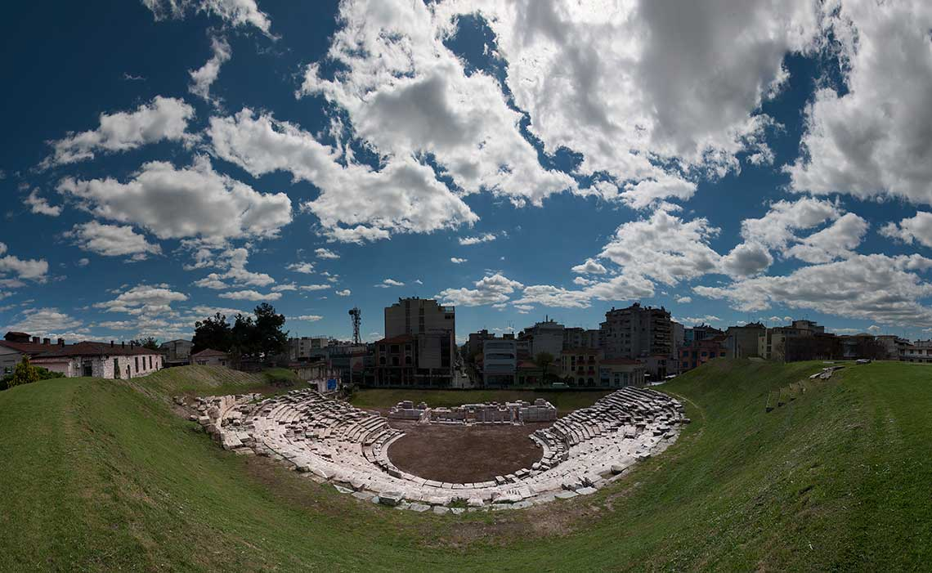

1st Ancient Theatre of Larissa, Greece, 300 BC

